Portfolio overview for the data story

* What was the project?
* Why did you make it?
* What skills, knowledges and processes di you use?
* What did you learn from the project?
* How was the project a success?

**To do**

* Portfolio overview
  + Outline
  + Write
  + Edit
* Introduction
  + Outline
  + Write
  + Figures
    - One
    - Two
  + Edit
* Falling dominance of top 20 percent countries
  + Outline
  + Write
  + Figures
    - One
    - Two
    - Three
    - Four
  + Edit
* A recovery, to some extent.
  + Outline
  + Write
  + Figures
    - One
    - Two
  + Edit
* Who was gaining as the top 20% fell? Outline
  + Outline
  + Write
  + Figures
    - One
  + Edit
* There have been sustain challenges for countries outside the top 50%
  + Outline
  + Write
  + Figures
    - One
    - Two
    - Three
  + Edit
* Concluding
  + Outline
  + Write
  + Edit
* Methods
  + Coding link to notebook (<https://rpubs.com/chrismartin03/964176>)
  + Narrative link to Figma Jam

**Introduction**

Almost all the media reporting on tennis focusses on the biggest stars in the game. Serena, Roger, Rafa and Novak. Players who are known just by their first names.

The broader trends in the game receive much less attention. I am thinking of questions like is the top tier of professional tennis becoming more accessible to players outside the very richest countries? After my years of watching tennis, I did have a hunch that this was the case.

In this data story, I explore if the data backs up my hunch. Before I get into the detail, lets quickly define what I mean by some of the key terms in the question.

* *The top tier of professional tennis:* I will consider entering the first round of a Grand Slam Singles tournament as being in the top tier.
* *The very richest countries:* Here, I am going to say that the richest countries are those with the highest GDP per capita. More specifically, the countries in the top 20% for GDP per capita.
* *My years of watching tennis:* I will look at a trends from 1990 up until 2019. This lines up with when I started watching tennis. The 1990 Wimbledon final between Edberg and Becker is the first one I remember (I think!). I am going to draw a line at 2019 though, after that I suspect any trends are going to be dominated by the effects of the Covid-19 pandemic.

In just the single chart below, we can see that the dominance of the very richest countries did decline between 1990 and around 2010. My hunch was right, at least initially. It looks like there is a bit of recovery, in Grand Slam first round appearances for these countries, after around 2010. The trend at each of the Grand Slam Tournaments looks similar. This is going to be important in a minute, but I will come back to that.

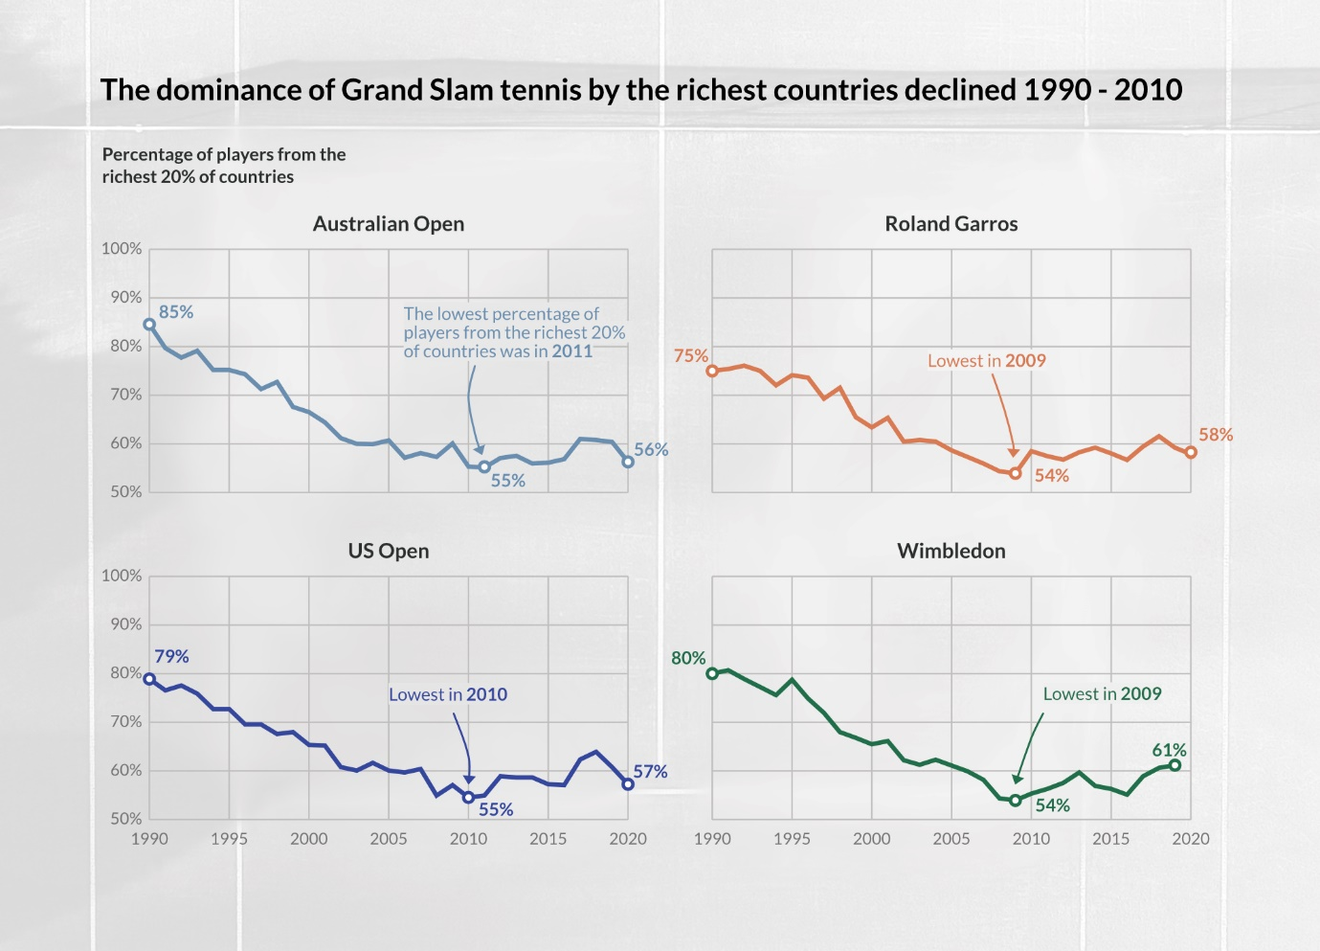

The change was dramatic too. In 1990 80% of players appearing in the first round of Wimbledon were from one of the very richest countries. By 2009 this had fallen to 54%. In raw numbers that equates to there being 205 players from the richest 20% of countries in the draw in 1990, and only 138 players in 2009.Now if we look at all Grand Slam tournaments together, then we see that the lowest percentage of players from the richest 20% of countries was in 2008.

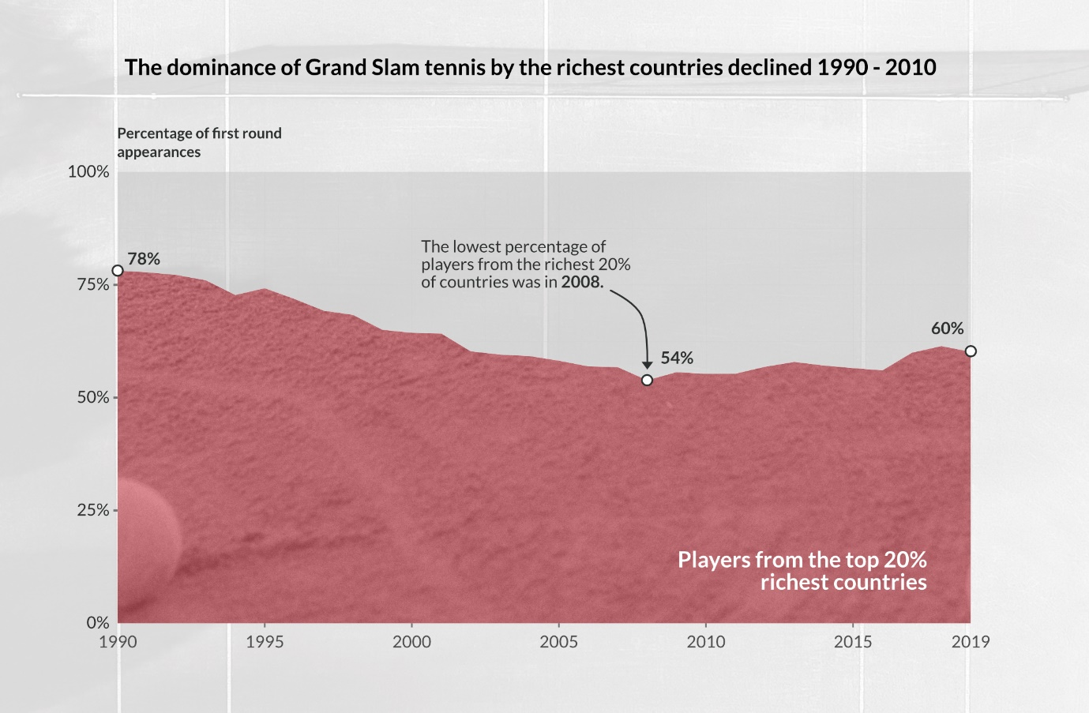

We will be looking at a few charts like this, with all the Grand Slam tournaments aggregated together and the ‘percentage of first round appearances’ on the y axis. So, it is worth being clear about what this means. 100% is equal to the 1024 first round appearances made each year. That breaks down as 256 first appearances at each Grand Slam, 128 in each of the Women’s and Men’s singles. There is a quick visual representation of this below, which might help as an explainer if things are not totally clear yet.



Before digging deeper into the trend I have identified, I want to quickly explain why I chose first round Grand Slam appearances as the ‘metric’ for assessing the performance of the richest countries. If you are a player competing in Grand Slam singles tournaments then you are probably breaking even financially or even earning money. If you are interested, there is lots to read about the financial difficulties faced by players outside the top 100 in the world. I would recommend this piece (<https://www.forbes.com/sites/miguelmorales/2013/08/26/aces-into-assets-how-michael-russell-has-made-a-profitable-career-in-the-demanding-world-of-pro-tennis/?sh=7bf3390e4754>) as a starting point.

Having set the scene and established there was something in my tennis fan’s hunch, I am going to digger a bit deeper. First, to explore what was going on as the dominance of the richest countries fell away, and then experienced a (mini) resurgence. Then turning to countries that made, and did not make, gains as the richest countries fell away.

**The richest countries falling away**

The first thing to do, is to confirm that the trends we looked at earlier in the story are meaningful, interesting and tennis related. This means ruling out some potential alternative explanations. Were there big changes over the years in which countries were in the top 20% richest? Did a major tennis playing country drop out of the top 20% richest countries sometime between 1990 and 2008?

It turns out this was not the case. The group of major tennis playing countries in the richest 20% of countries remained stable. There is a group of countries that has been ever present in the richest 20%. This group includes the countries that have dominated Grand Slam tennis, such as the United States, France and Spain. In the chart below, you can see a second group that did move in and out of the top 20% richest countries. However, these are not countries which have had large numbers of players appearing at Grand Slams. Mostly, they have had fewer than 10 appearances per year.

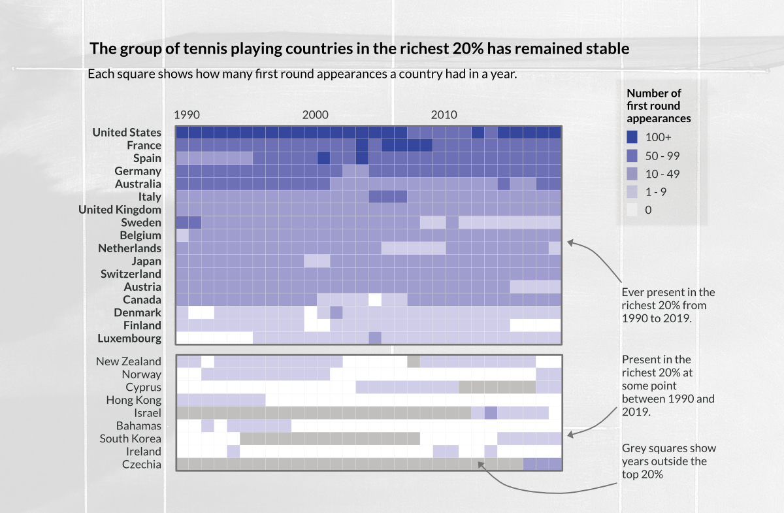

So, having ruled out one potential explanation, I will focus in why the dominance of the richest countries declined between 1990 and 2008. If we compare each countries performance - in term of the number of first round Grand Slam appearances - between 1990 and 2008, we can see four groups. Countries where performance has:

* Improved (France and Spain);
* Been fairly stable (most countries in the top 20% richest);
* Declined (Australia and Sweden);
* Declined a lot (the United States).

Looking at all the richest 20% countries together, they account for 78% of first round appearances in 1990. This has fallen to 54% of first round appearances by 2008. That fall of equates to 246 fewer first round appearances. The chart below shows what this drop off looks like.

We have already identified the three countries with the biggest declines in performance. The United States, Australia, and Sweden. Looking at just these three countries, they account for 40% of first round appearances in 1990. This has fallen to 14% of first round appearances by 2008, equating to 266 fewer first round appearances. The fading fortunes of just three countries was central to the decline in dominance of Grand Slam tennis by the richest 20%.

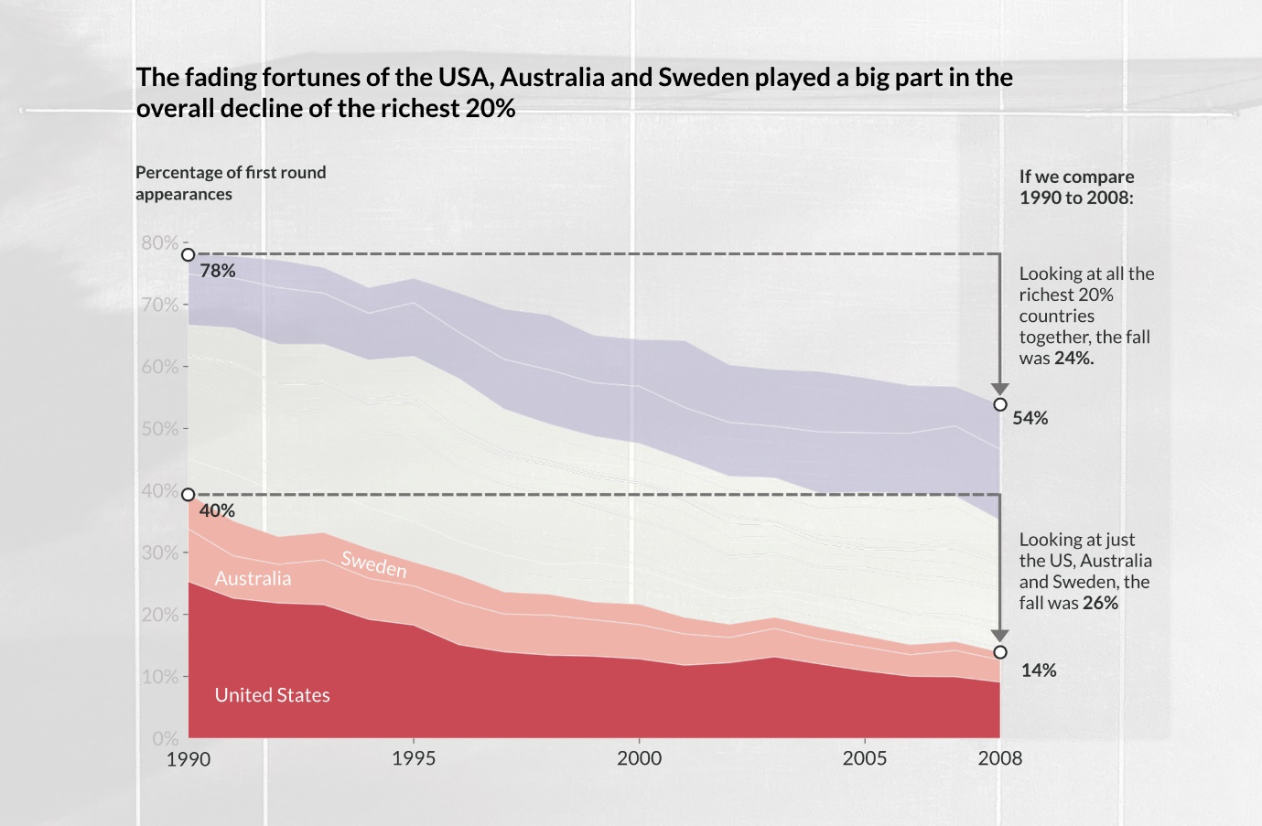

Zooming in even further, and looking at the transformation in the fortunes of United States, we can see a huge drop off. The United States accounted for a quarter of all players appearing in Grand Slam singles in 1990. In the chart below it was hard to know which legendary players to note, with 106 different USA players appearing in Grand Slams in 1990. In the end, there was not space on the chart for multiple Grand Slam winners including Andre Agassi. In contrast by 2008, it was much easier to pick out a few headline names, from a much smaller pool of players (41).

After hitting a low point in 2008, there was a resurgence in the fortunes of the richest countries in the years that followed. By 2019 the richest countries accounted for 60% of the first-round appearances at Grand Slams. That is around the level they were at in 2002, but well below the where they were at in 1990 (78%).

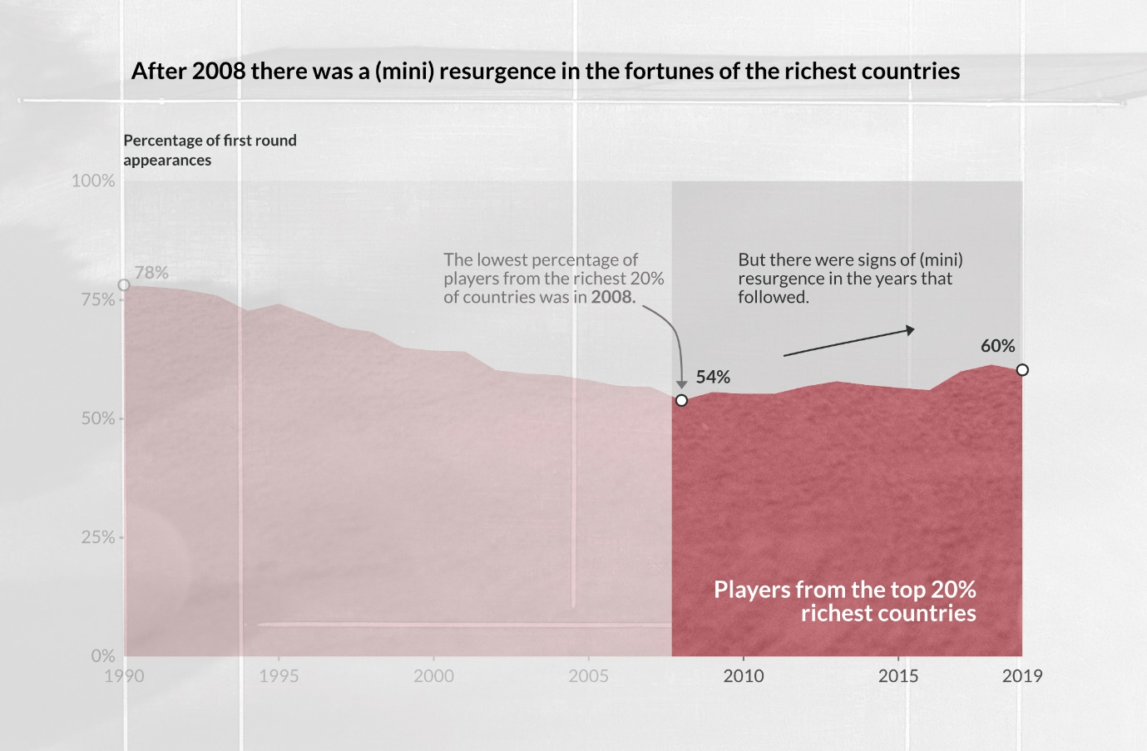

By 2008 the United States had lost its position as the most successful tennis nation. France was the best represented country in the first round of Grand Slams at that time. From 2009 things pick up again for the United States and drop off a little for France. So, by 2012 the United States was once again the top performing country. The United States continued to rebuild its strength over the 2010s, playing a big part in the (mini) resurgence of the richest countries. Just as the fortunes of the United States had played a big part in the decline of the richest countries between 1990 and 2008.

**Which countries made gains up until around 2008?**

While the United States, and some of the other richest countries, where losing ground over the 90s and 00s, some countries were seeing huge growth. Particularly, Russia, Czechia and Argentina. These countries, from outside the richest 20% all saw big increase in the number of players appearing at Grand Slams. They became the best performing countries outside the richest 20%, and their peak performing years (shown with small triangles in the chart below) all came around 2005 – 2007.

However, there have been sustained challenges for lower income countries. Those in the bottom 50%, in terms of the GDP per capita. The chart below shows the how many countries, for the bottom 50%, were represented at Grand Slams each year. This grew from 1990 and peaked in 2003 and 2004. During each of these years, 17 lower income countries were represented. Countries including Belarus, China, Madagascar, Paraguay, Uzbekistan and Zimbabwe. However, by 2013 the gains made in the 1990s had been lost, only 4 lower income countries where represented at the Grand Slams.

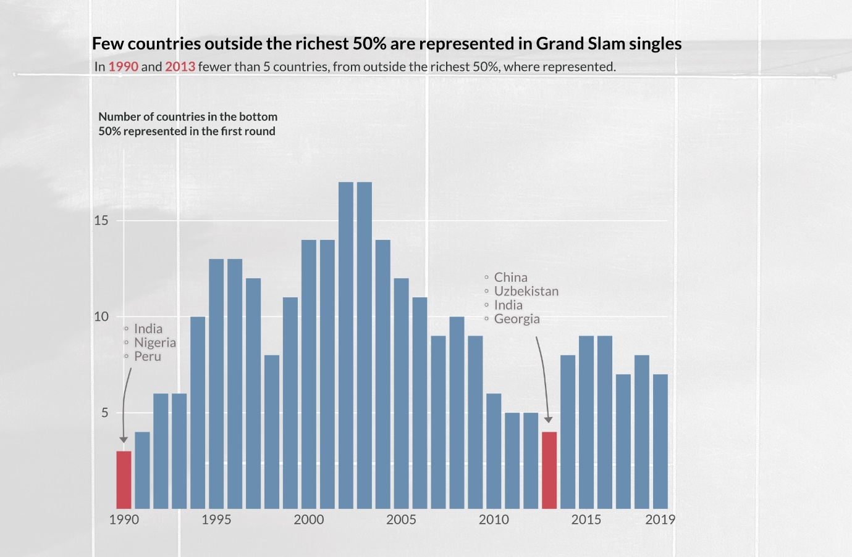

Regardless of the shifting fortunes of the richest countries, Grand Slam tennis has remained inaccessible to players from many countries including those across large parts of Africa, Asia and Central and South America. The animated map below, shows in red the countries **not** represented at Grand Slams each year. This highlights the persistent difficulties faced in top level professional tennis becoming a truly global game.

That is, it for my exploration of my tennis fan’s hunch that Grand Slam tennis has beyond slightly more open to players outside the richest countries. It is difficult to unpick what has been driving the trends explored above. They probably are a result of a constellation of different social and economic factors playing out at local, national and international scales. Factors including economic development, tennis governance, sporting infrastructure and the strength of the community game. If I had to choose somewhere to start with unpicking it all, it would be based on another hunch.

* Top level professional tennis remains largely inaccessible to players from lower income countries due to the sheer expense of getting to a Grand Slam. The infrastructure needed just to start playing, tennis courts and clubs, is expensive. Huge personal investment, both time and money, is also needed to construct a professional career. Years of coaching starting early in childhood, travel to junior tournaments, and years of international travel on the professional tour before reaching a Grand Slam.
* There is the potential for the richest counties to face a renewed challenge from middle income countries. As the most economically privileged sections of the middle income countries grow richer, the pool of people with the financial resources needed to make a Grand Slam appearance grows too.

**Methods**

To produce the chart, I needed data on the women’s and men’s singles entrants for each Grand Slam tournament since 1990. This came from the excellent [Tennis Abstract](https://github.com/JeffSackmann). I also needed data on the wealth of countries. This came from [Our World in Data](https://ourworldindata.org/grapher/gdp-per-capita-worldbank?tab=chart).